**Arun Mitra**

[LinkedIn](https://linkedin.com/in/arun-mitra)

[GitHub](https://github.com/ArunMitra)

[SlideDeck](https://docs.google.com/presentation/d/1llDWw1CZnVNnt9pYn2KFhu77x0qj40jf3ZRmRBVnCw8/edit?usp=sharing)

**Short Bio**:

My career started in software development and from there I transitioned into project management, engagement management, customer success management, and, in the last 15 years, software business development. The big reset this year has allowed me time to refresh my technical roots. With the explosion of data and the awesome distributed cloud-based computing power now so easily available, I cannot wait to get to work with applied data science - there is just so much to be done to add value to businesses, to non-profits, and, in general, to the quality of life of everyone on the planet.

**Capstone Project Name:**

**“Tea buy, or not tea buy, that is the question” -- Wholesale Tea Price Predictions**

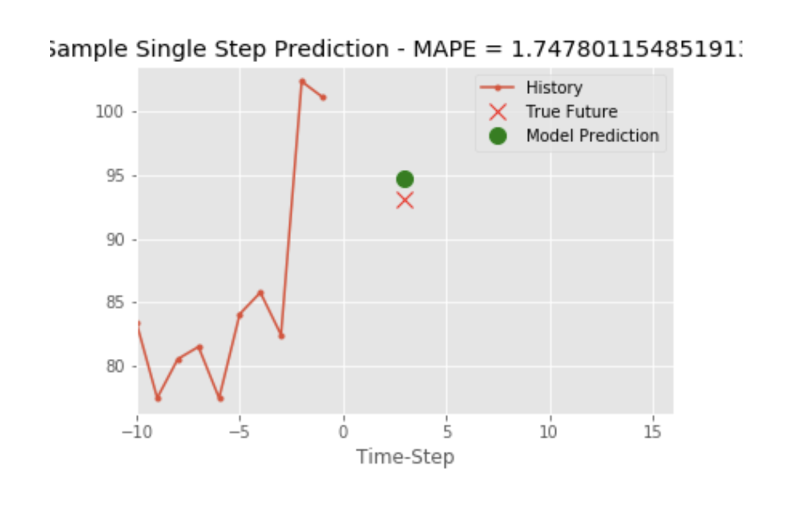

**Short Summary of Project:**

The tea business is big and complex in India, one of the world’s largest manufacturers. Any good price forecasts will help sellers, buyers, and auctioneers to bring efficiencies to their business. In this project, I learned to use ARIMA time series models, TensorFlow, and RNN/LSTM. I learned to use cloud resources to run deep model training tasks.  
I have seen how well-considered features can add power to multivariate time series forecasting.

**Tech Stack Used:**

Python - Pandas, NumPy, Matplotlib, Sci-kit Learn, Statsmodels, pmdarima, AWS EC2

**Fun Fact:** I have enjoyed countless hours playing online chess, solving problems. I now enjoy those hours even more solving problems with my new passion - data science.